2.4 I can use and apply industry standard testing regimes and (describe) project management testing techniques

V – Model testing (Verification and Validation Model) is an industry standard testing model for software development. The model is best suited to short to medium term projects with well-defined requirements. The testing process takes place in a sequential manner, in the shape of a V;

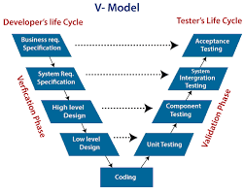

javatpoint.com

Each test has a corresponding test, meaning that for every test you carry out you also need to complete the corresponding test to carry on to the next stage.

There are several phases of the V-Model;

* Business requirement analysis
* System Design
* Architecture Design
* Module Design
* Coding Phase

Verification tests are listed on the left side of the v- model, whilst the corresponding validation tests make up the right side of the model.

Verification phase – Testing is done by without executing the code. The product development phase is evaluated to check if the requirements are met

Validation phase – Testing is done by executing the code to check if it meets end user requirements